Parallel and MultiThreaded Programming

CSYE 7215

Homework 9

Due: November 21, 2020

**1. Write declarations for the following:**

**a pointer to a character,**

*char charValue = ‘a’;*

*char *pointerToChar = &charValue;*

**an array of 10 integers,**

*int arr[10] = {1,2,3,4,5,6,7,8,9,10};*

**a reference to an array of 10 integers,**

*int (&refrenceToArr)[10] = arr;*

**a pointer to an array of character strings,**

*char str[3] = {'a','b','c'};*

*char *ptr =str;*

**a pointer to a pointer to a character**

*char charValue = ‘a’;*

*char* ptr1 = &charValue;*

*char** ptr2 = &ptr1;*

**a constant integer,**

*const int CINT= 10 ;*

**a pointer to a constant integer,**

*const int * ptr;*

**constant pointer to an integer**

*int * const ptr;*

2. Draw Memory Map for the following code, Explain:

a)

int x=4;

int *ptr1=&x;

printf(x, &x, ptr1, *ptr1);

* In Given code snippet we are creating pointer ptr1 which is pointing to address of x.

|  |  |  |  |  |  |  |  |
| --- | --- | --- | --- | --- | --- | --- | --- |
| Ptr1 |  |  |  |  | X=4 |  |  |

b)

long a[] = {6, 0, 9, 6};

long *ptr1 = a;

ptr1++;

long * ptr2 = a + 3;

**In Above code snippet we are creating an array of long and initially ptr1 is pointing to 0th index of the array after that we increment the address so ptr1 now point to 1st index of an array then we are assigning address of 3rd index to pointer ptr2**

|  |  |  |  |  |
| --- | --- | --- | --- | --- |
| 6 | 0 | 9 | 6 |  |

*ptr1 = a; ptr1++ ptr2=a+3

|  |  |
| --- | --- |
| Ptr1 | Ptr2 |

c) Explain similarities and differences between these two declarations:

char courseName1 [] = {’6’, ’.’, ’0’, ’9’, ’6’, ’\0 ’ };

char * courseName2 = " 6.096 ";

* Similarities
* String is array of characters so we can declare a string by using character pointer which points to first index of array or we can simply declare the array of characters
* When you set a char * to a string, you are really setting a pointer to point to the first character in the array that holds the string
* Difference
* We **can not modify the string literals.**
* Attempting to modify one of the elements **courseName1 is permitted**, but attempting to modify one of the characters in **courseName2 will generate a runtime error**

3. Write a program to create int variable x with value 5.

a) declare int pointer variable ptr1

b) assign a valid address to ptr1

c) print x, &x, ptr1, *ptr1

d) declare int pointer ptr2

e) assign ptr1 to ptr2

f) print x, &x, ptr1, *ptr1, ptr2, *ptr2. // everthing is point to x

g) assign *ptr1=8

h) print x, &x, ptr1, *ptr1, ptr2, *ptr2. // everything is point to 8 value of x would be 8

**i) compare (h) and (f), Explain**

j) assign *ptr2=15

k) print x, &x, ptr1, *ptr1, ptr2, *ptr2

**l) i) compare (k) and (h), Explain**

m) declare int array arr = {4, 12, 8, 6}

**n) assign *ptr1 to array arr**

p) increment ptr1 four time, at each iteration, print ptr1, *ptr, &arr, arr[i], ptr2, *ptr2

q) Explain

int* ptr1; //declare pointer to int

int x =20;

ptr1= &x; // assign valid integer

printf("printf C %d %x %x %d", x, &x, ptr1, *ptr1); // print x, &x, ptr1, *ptr1

printf("\n");

int* ptr2; // declare ptr2

ptr2 = ptr1; // assigne ptr1 to ptr2

printf("printf f : %d %x %x %d %x %d", x, &x, ptr1, *ptr1, ptr2, *ptr2); // (f)

printf("\n");

*ptr1=8; //(g)

printf("printf h : %d %x %x %d %x %d",x, &x, ptr1, *ptr1, ptr2, *ptr2); (h)

printf("\n");

*ptr2=15; //(j)

printf("printf k : %d %x %x %d %x %d",x, &x, ptr1, *ptr1, ptr2, *ptr2); // (k)

printf("\n");

int arr[] = {4, 12, 8, 6}; //m

ptr1 = arr; // (n)

for(int i =0 ; i <4 ;i++){

printf("printf p for %d : %x %d %x %d", i , ptr1, *ptr1, ptr2, *ptr2); //(p)

printf("\n");

ptr1++;

}

**Output:**

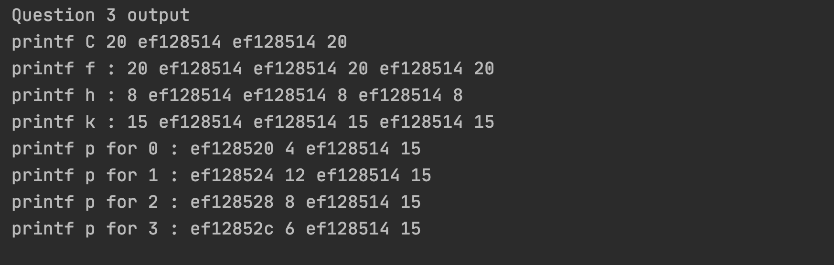

**Explain:**

* First we are creating integer pointer ptr1 an assign valid integer address to that pointer
* After that we are creating new integer pointer **ptr2** which is pointing to **ptr1**

Ptr2 🡪 ptr1 🡪 address of x (20)

* Now we are changing the value of x by assigning 8 to ptr1

Ptr2 🡪 ptr1 🡪 address of x (8)

* So now value of ptr1 ,ptr2 and x would be 8
* If we **compare the result of (h) and (f)** we can see from output that value of x is changed from 20 to 8 and ptr1 and ptr2 are pointing to same address (address of x ) hence the value of both pointer is 8.

After this we have changed the value of x using ptr2 using *ptr2=15

Ptr2🡪 ptr1🡪 address of x (15)

* Now if we compare the result of I, k, and h we can see the different value of x like 20, 8 and 15.
* At the end we have defined array of integer and iterate through an array using pointer.

4. Explain “pass-by-value” in Java and “pass-by-reference” in C/C++, provide examples

**Pass by value :**

It is a process in which th**e function parameter values are copied to another variable and instead this object copied is passed**. This is known as call by Value.

* For better understanding let’s consider the example of swap two integer in java
* In swapInteger function we are passing two instance of Integer class and swap the value
* Check the following code snippet of swapInteger program and output of the program we can clearly see in output **that actual value of integer I1 and i2 is not changed .**

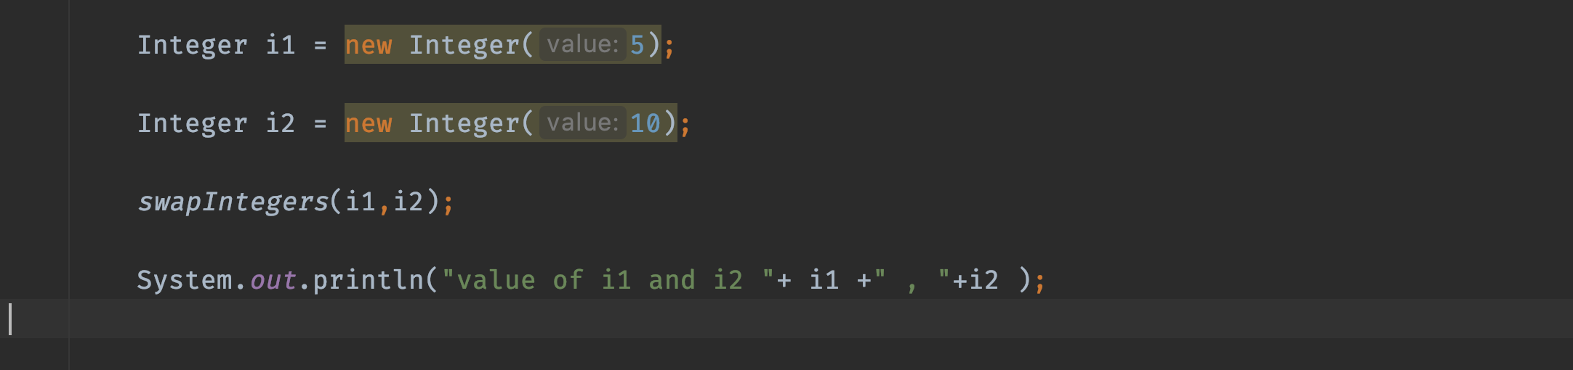

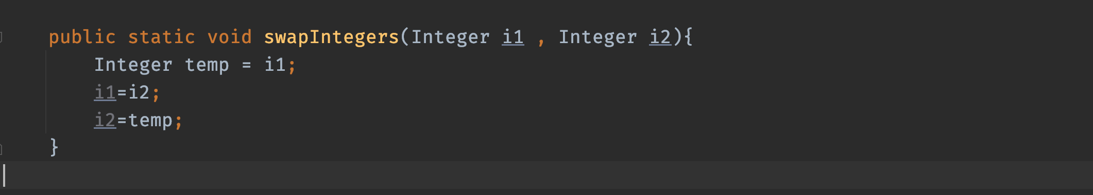

**Output**

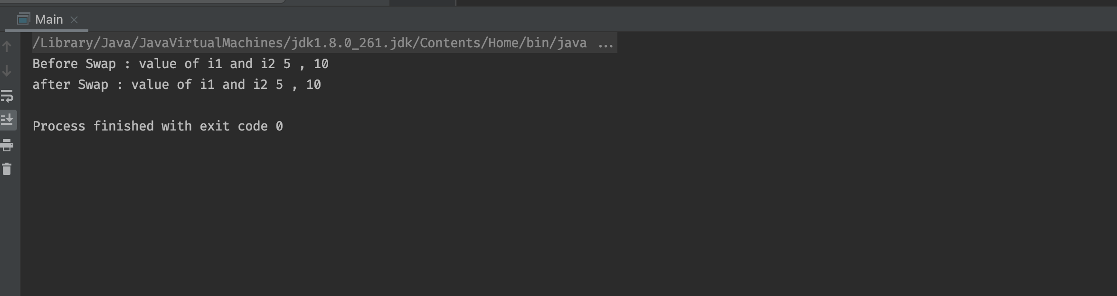

**Pass by Reference**: It is **a process in which the actual copy of reference** is passed to the function. This is called by Reference.

* To better understand pass by reference find the attached screen shots of swapInteger function in cpp.
* In Following program I am printing the value of x and y before and after calling swapByreference function.
* We can check the output screenshot which shows that value of x and y is swapped.

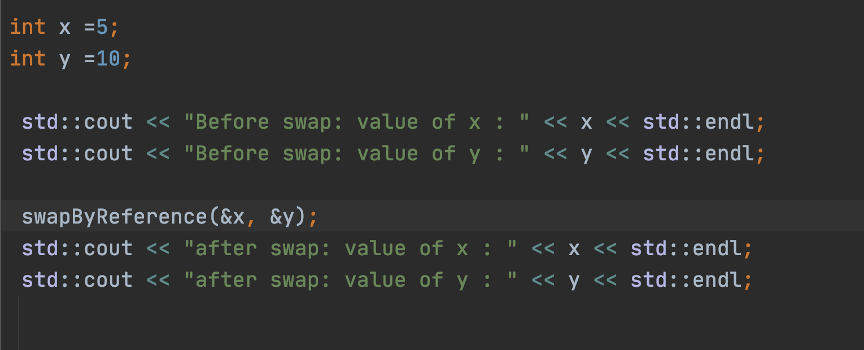

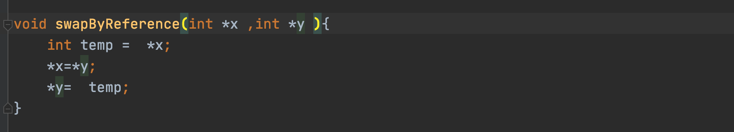

**Output**

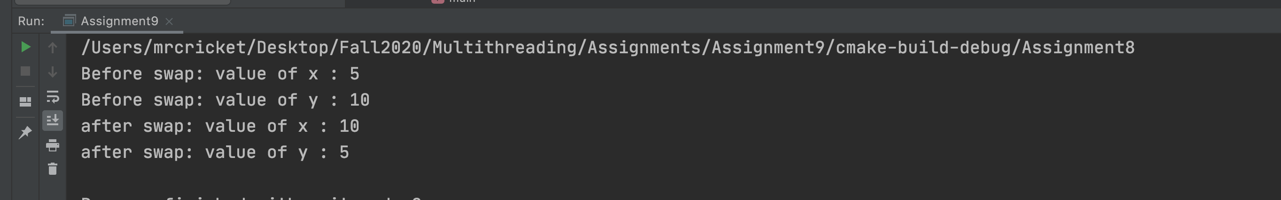

**5. Compile and Run the following program:**

A) Compile: gcc program1.c -o program1

B) Explain code

C) Explain Outputs

#include <iostream>

using namespace std;

int main() {

float arr[3];

// declare pointer variable

float *ptr;

cout << "Displaying address using arrays: " << endl;

// use for loop to print addresses of all array elements

for (int i = 0; i < 3; ++i) {

cout << "&arr[" << i << "] = " << &arr[i] << endl;

}

// ptr = &arr[0]

ptr = arr;

cout<<"\nDisplaying address using pointers: "<< endl;

// use for loop to print addresses of all array elements

// using pointer notation

for (int i = 0; i < 3; ++i) {

cout << "ptr + " << i << " = "<< ptr + i << endl;

}

return 0;

}

Output :

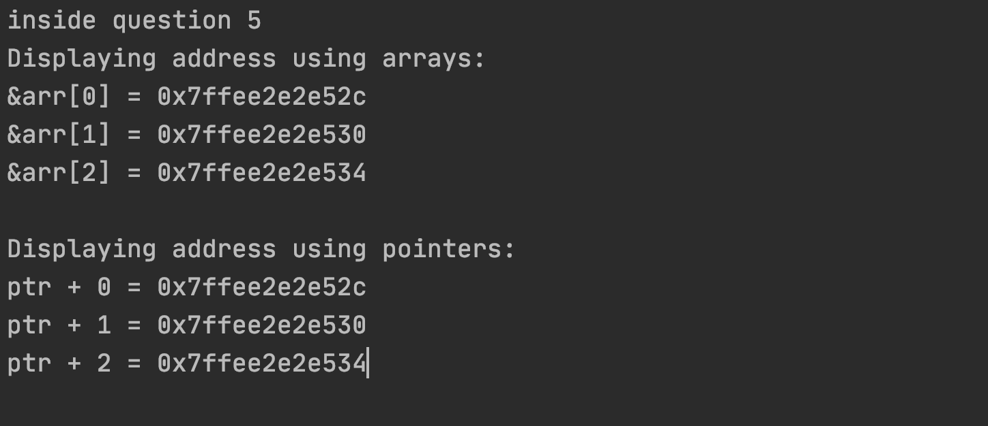

**Explain Output:**

* In. given program we are creating an array of float size of 3 and then we are iterating through each element and printing address of ach element.
* In first for loop we are accessing the address of each element by using “&” for example &arr[i]
* In second for loop we are access the address of each element using pointer, as we know that array store in continuous address so we are simply incrementing the pointer and accessing each element.

6. Write a function that swaps two integers. A) Java B) C/C++, use int* as a argument type.

**Swap integer is java**





**Swap Two Integer in C++:**







7. Evaluate and Explain the correctness of these code:’

A)

class Integer {

public: int val;

Integer(int v) { val = v; } };

int main() {

Integer a[] = {

Integer(2),

Integer(5) };

Integer b[2];

}

Explain:

* In CPP if the default constructor is not defined then we need to set the default value when we declare a new variable.
* In above code snippet default **constructor is not available** so **Integer b[2];** **will not work and throw and error: No default constructor available for Integer**
* **We can correct this program by assigning default value of by creating a default constructor in Integer class**

B)

class Integer {

public: int val;

Integer(int val = 0) {

this->val = val;

}

void setVal(int val) {

this->val = val;

}

}

Explain:

* Above code snippet show that how to access the instance variable when the name of instance variable and local variable is same
* We can access the instance variable using “->” sign

this->val = val; // here we are setting value for instance variable using local variable.

C)

int main() {

int *p;

if (true) {

int x = 5;

p = &x;

}

cout << *p << endl; // ???

}

**Explain:**

* In CPP if we are declaring new variable without using “New” keyword **then the de allocation of memory will be done once that variable goes out of scope**
* **In above program P is point to address of x but x goes out of scope outside the if condition so *p will return dangling pointer**

D)

int* getPtrToFive() {

int x = 5;

return &x;

}

int main() {

int *p = getPtrToFive();

cout << *p << endl;

}

Explain:

* In above code snippet x is declared in the function scope and getPtrToFive return address of x
* **Now in main method we are assigning address of x to pointer p using getPtrToFive() but x goes out of scope here, So a dangling pointer is returned**

E)

int *getPtrToFive() {

int *x = new int;

*x = 5; return x;

}

int main() {

int *p = getPtrToFive();

cout << *p << endl;

delete p; }

Explain:

* In CPP we can assign memory to variable using “**NEW**” keyword but we need make sure when we are de-allocating that memory after the use of that variable using delete operator
* **In Above program we are assigning memory to x using new keyword and then de-allocate the memory using delete at the end of program**

F) Does this code work? If not, how to fix it?

int *getPtrToFive() {

int *x = new int;

*x = 5;

return x;

}

int main() {

int *p;

for (int i = 0; i < 3; ++i) {

p = getPtrToFive();

cout << *p << endl;

**// Delete p;**

}

}

**Explain**:

* In CPP If we are not de-allocate unused memory using delete, your application will waste memory
* In above code snippet we are not deallocating memory so we need to put **delete p inside the for loop.**

8. Consider the following Java code which reverses two-dimensional array.

a) Compile the Java code and Run.

b) Rewrite Java code in C++

c) Compile and run the code

Public class reverse {

public static void main(String[] args) {

int[][] array = {

{ 1, 2, 3, 4 },

{ 5, 6, 7, 8 }

};

int rows = array.length;

int cols = array[0].length;

int[][] reverse = new int[rows][cols];

for(int i = rows-1; i >= 0; i--) {

for(int j = cols-1; j >= 0; j--) {

reverse[rows-1-i][cols-1-j] = array[i][j];

}

}

for(int i = 0; i < rows; i++) {

for(int j = 0; j < cols; j++) {

System.out.print(reverse[i][j]);

if(j < cols-1)

System.out.print(", ");

}

System.out.println();

}

} }

Output In Java

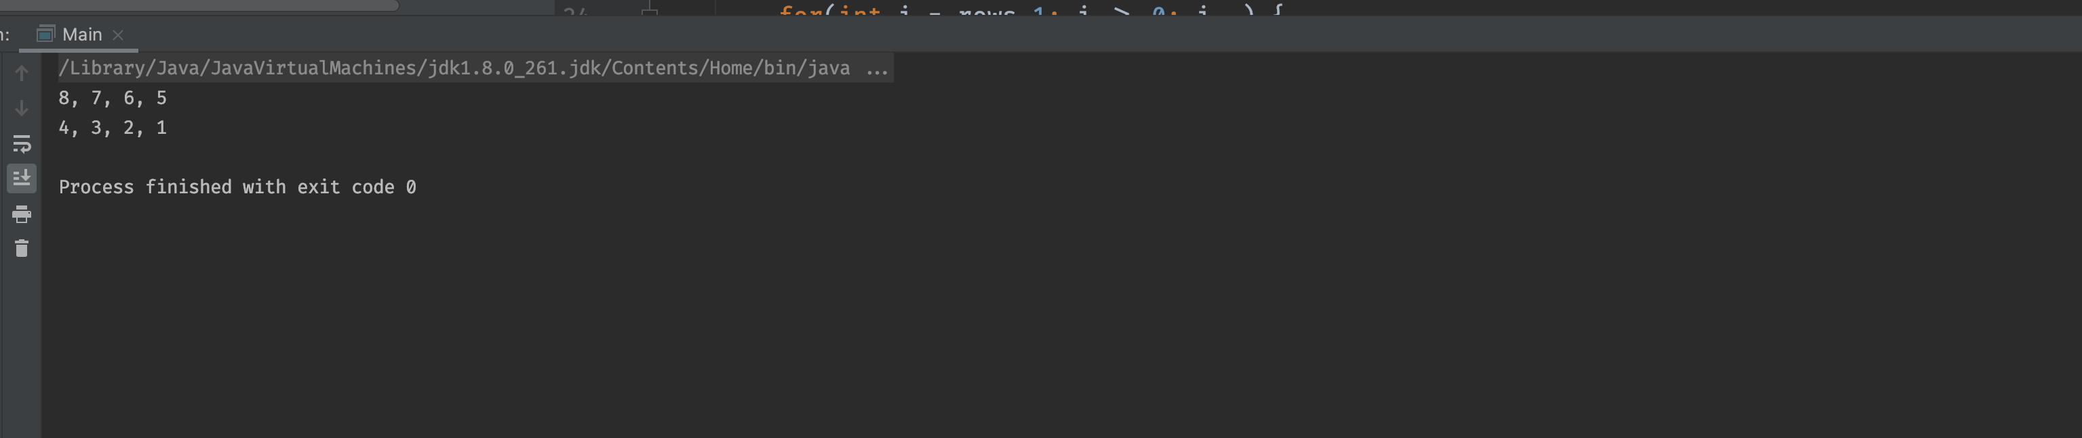

Program in C++

int array[2][4] ={  
 { 1, 2, 3, 4 },  
 { 5, 6, 7, 8 }  
};  
  
int rows = sizeof(array)/sizeof(array[0]);  
int cols = sizeof(array[0])/sizeof(array[0][0]);  
int reverseArray[rows][cols];  
  
printf("rows: %d , columns : %d ", rows,cols);  
printf("\n");  
for(int i = rows-1; i >= 0; i--) {  
 for(int j = cols-1; j >= 0; j--) {  
 reverseArray[rows-1-i][cols-1-j] = array[i][j];  
 }  
}  
  
for(int i = 0; i < rows; i++) {  
 for(int j = 0; j < cols; j++) {  
 printf("%d", reverseArray[i][j]);  
 if(j < cols-1)  
 printf(", ");  
 }  
 printf("\n");  
}

Output in C++:

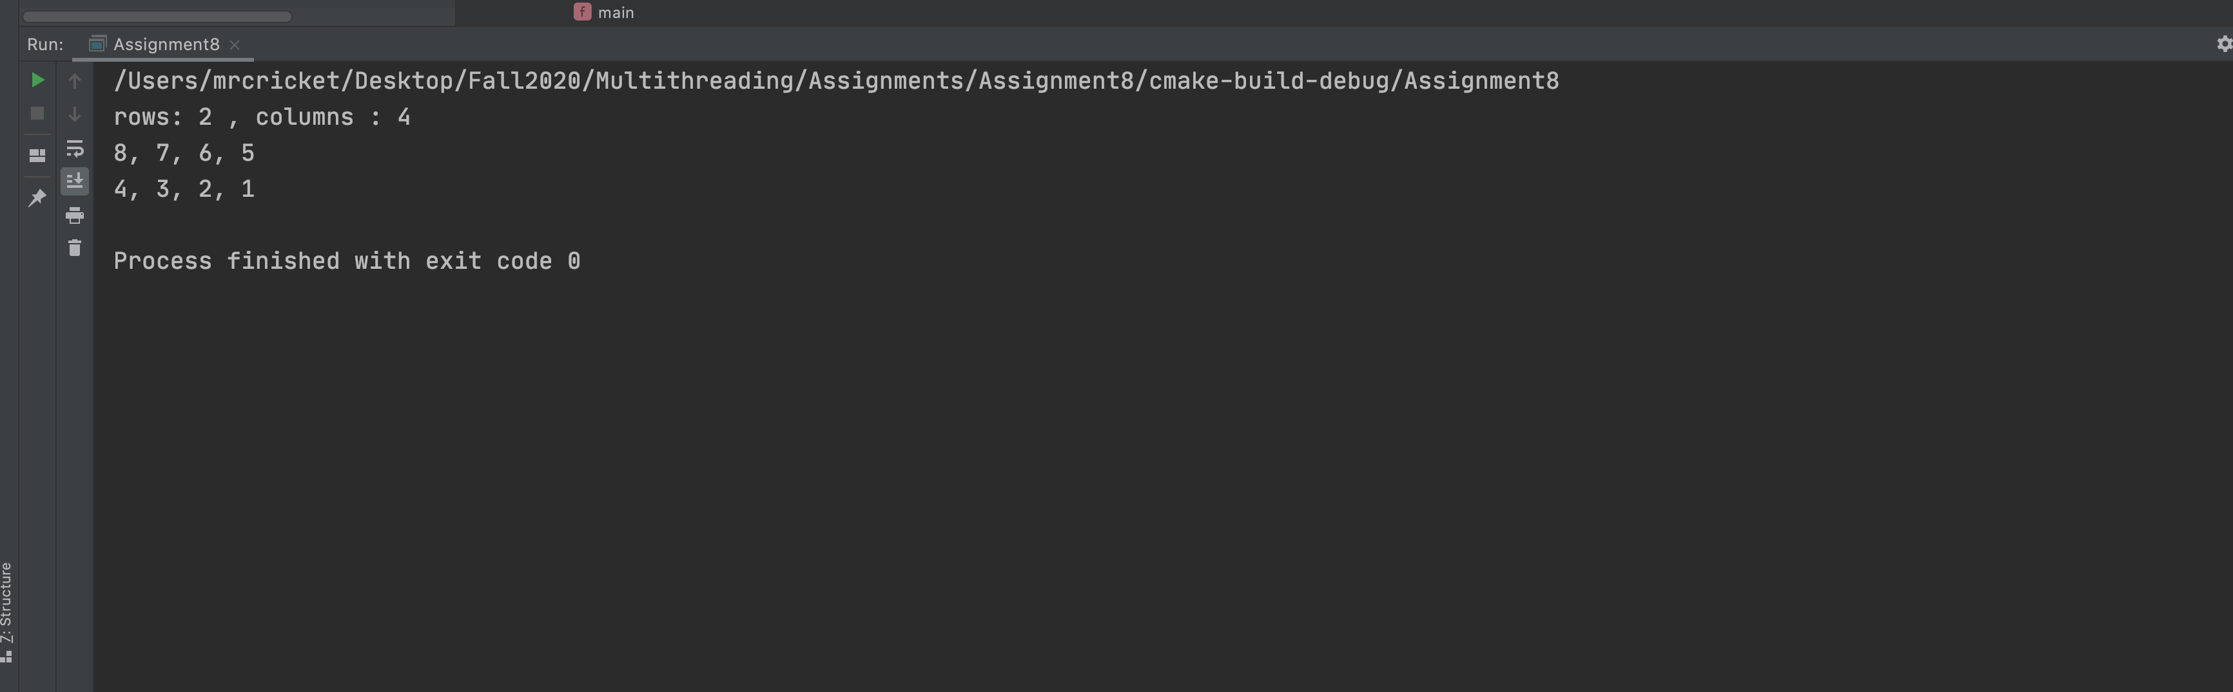

9. Consider this Threads code:

http://www.yolinux.com/TUTORIALS/LinuxTutorialPosixThreads.html

A) Compile and Run Code

B) Explain code and Outputs

C) Write Mutex lock mechanism to protect two Threads in this C++ Posix program:

Output:

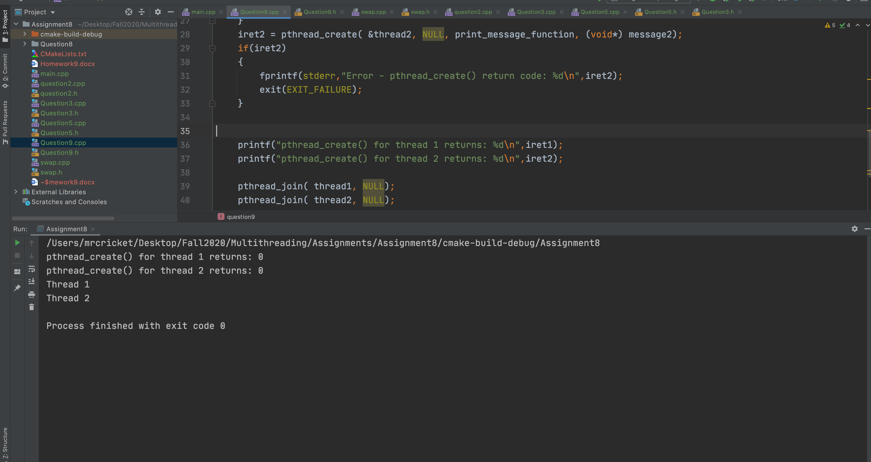

Explain Code and output :

* In Given program we are creating 2 threads using the POSIX library function **pthread_create** function.
* First we are defining two variable thread1 and thread2 type of pthread_t.
* Then we are passing the address of this two thread in pthread_create function with other arguments.
* The function return 0 if it creates the thread without any error else it will return > 0 value.
* To verify the what thread_create returns we have print the value in output.

pthread_create() for thread 1 returns: 0

pthread_create() for thread 2 returns: 0

* At the end of program we have used the pthread_join() method to makes sure that main thread will not get terminated before the thread 1 and thread 2.

C) Writes MUTEX lock mechanism:

pthread_mutex_t mutex1 = PTHREAD_MUTEX_INITIALIZER;  
int counter = 0;

pthread_mutex_lock( &mutex1 );  
counter++;  
printf("Counter value: %d\n",counter);  
pthread_mutex_unlock( &mutex1 );

* Mutual exclusion lock will block access to variables by other threads. This enforces exclusive access by a thread to a variable or set of variables.
* In give program we are trying to increment the counter variable using multiple threads
* If run the program without mutex lock the counter would be 1 as both the thread will not get the updated value of counter.

Possible execution sequence without mutex (assuming both thread are running concurrently)

Thread 1 🡪 counter (value 0) 🡪counter++ ( value 1 )

Thread 2 🡪 counter (value 0) 🡪counter++ ( value 1 )

* While using mutex lock it will make sure that only 1 thread can update the value of counter and mean while other thread will be blocked until it gets available.
* Hence we can see in the output that we always gets updated counter value

Output :

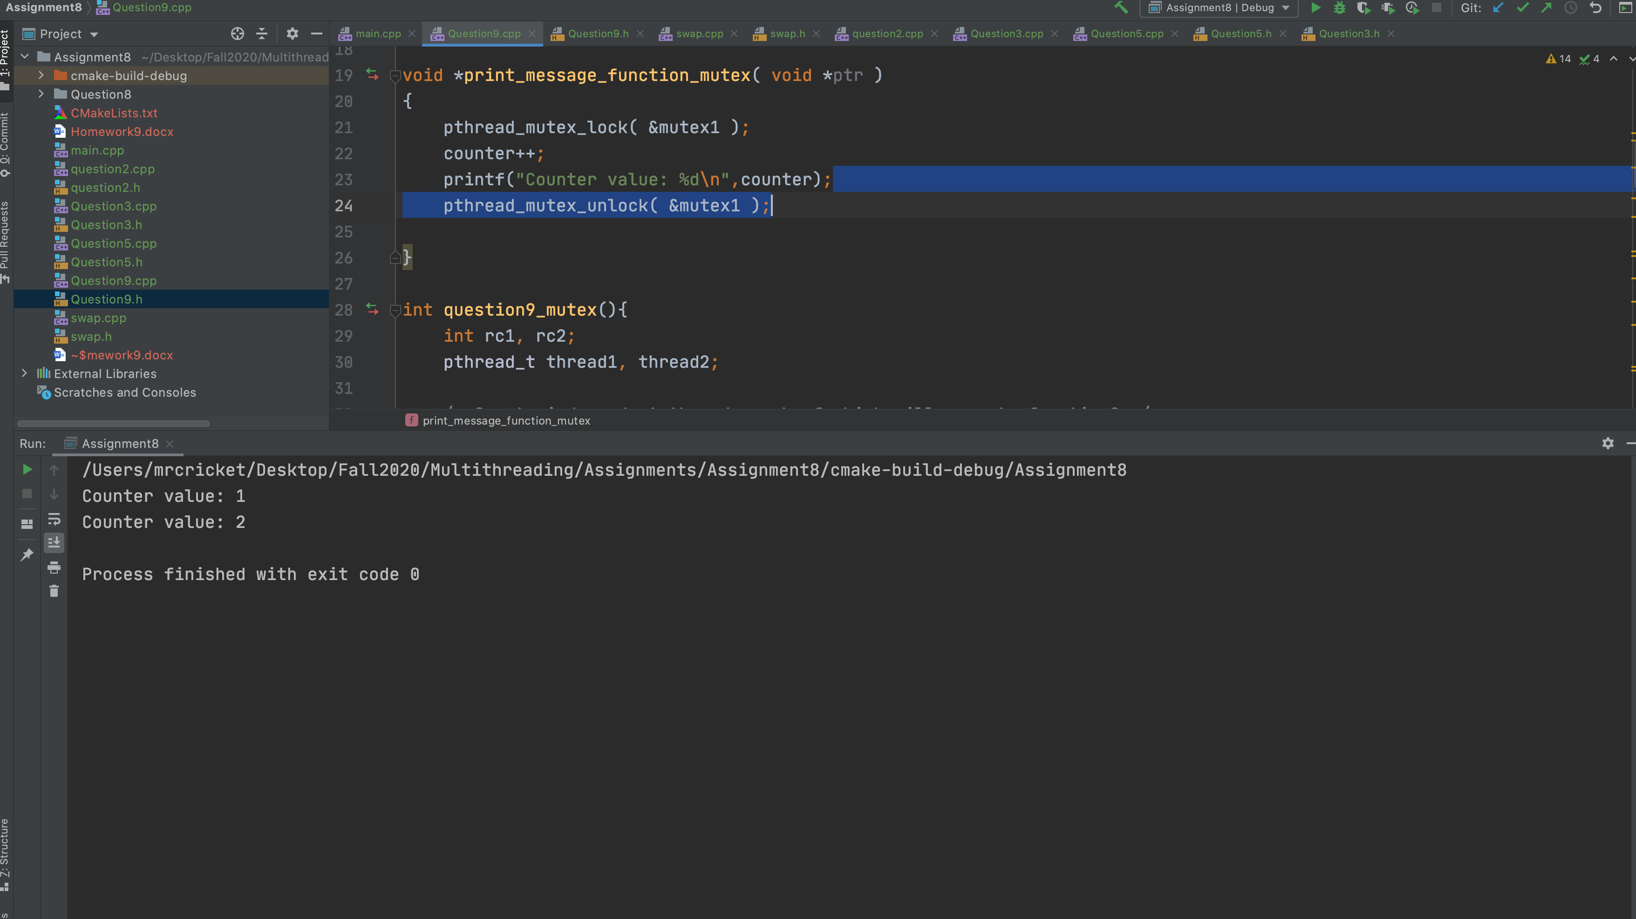

10. Consider JNI examples I discussed in class. Compile and Run, Show outputs

https://chandruscm.wordpress.com/2015/08/10/how-to-use-jni-java-native-interface-with-cc/

1. **HelloWorld from C**

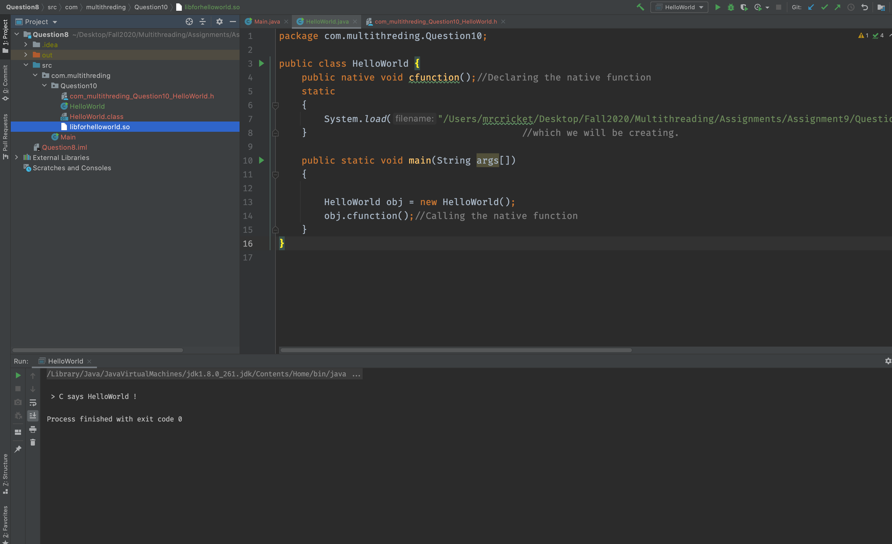

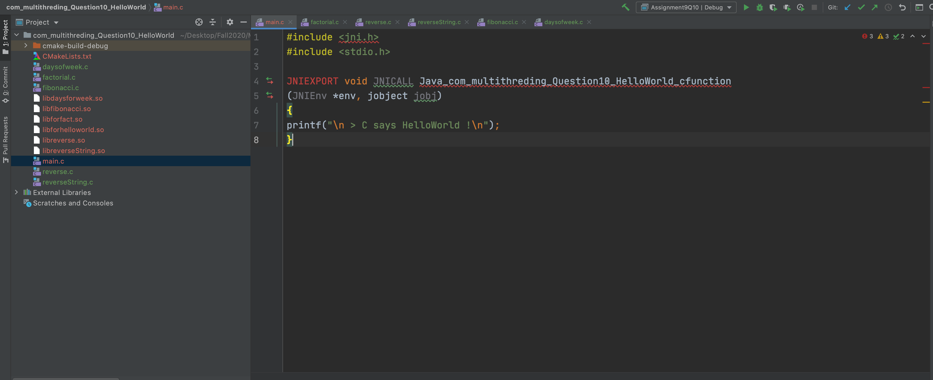

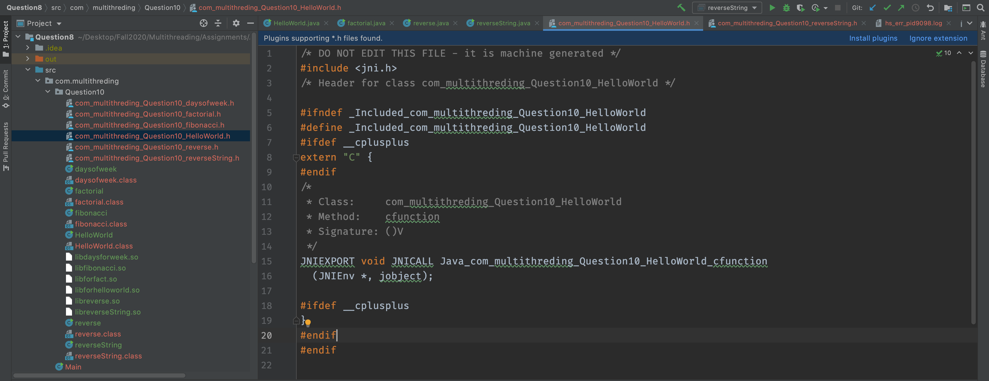

1. **Pass Integers From C to Java**

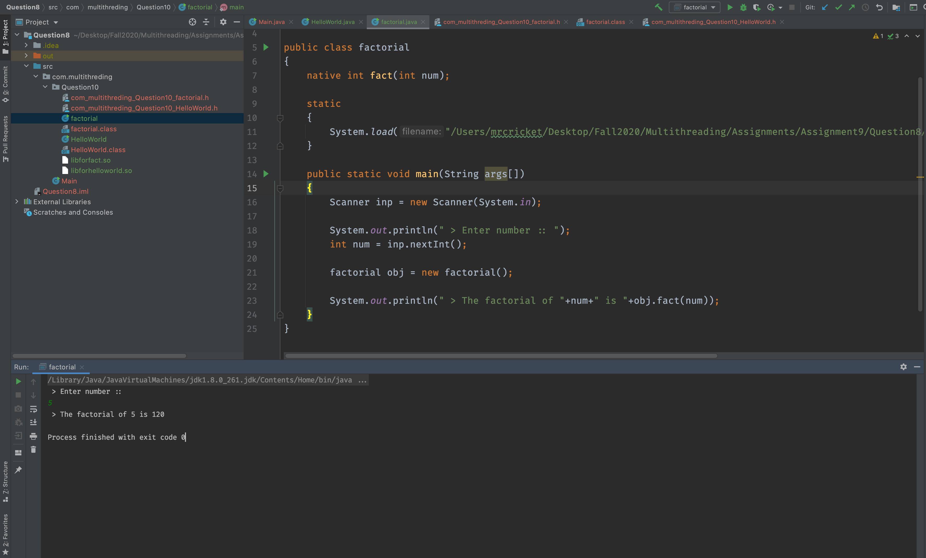

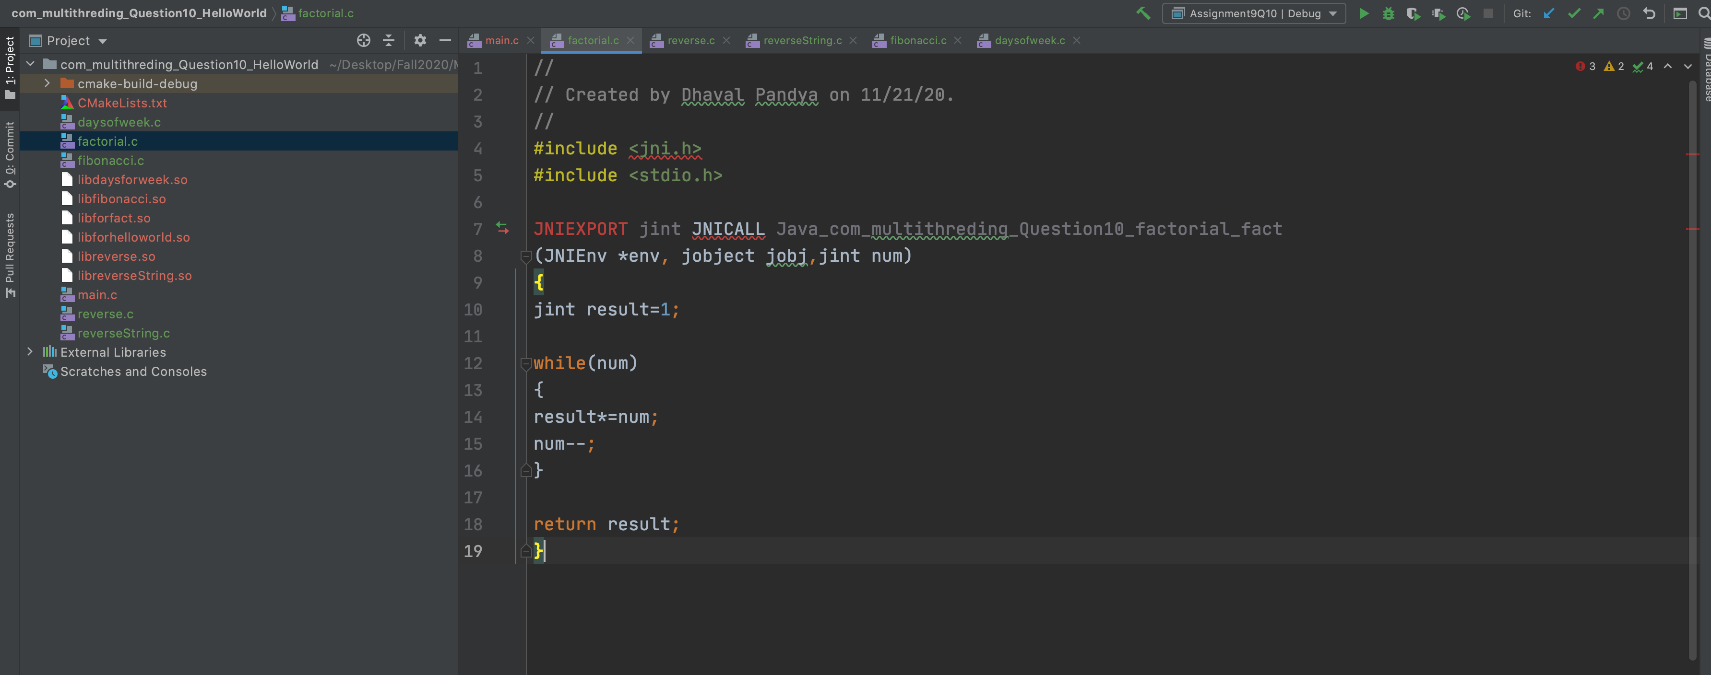

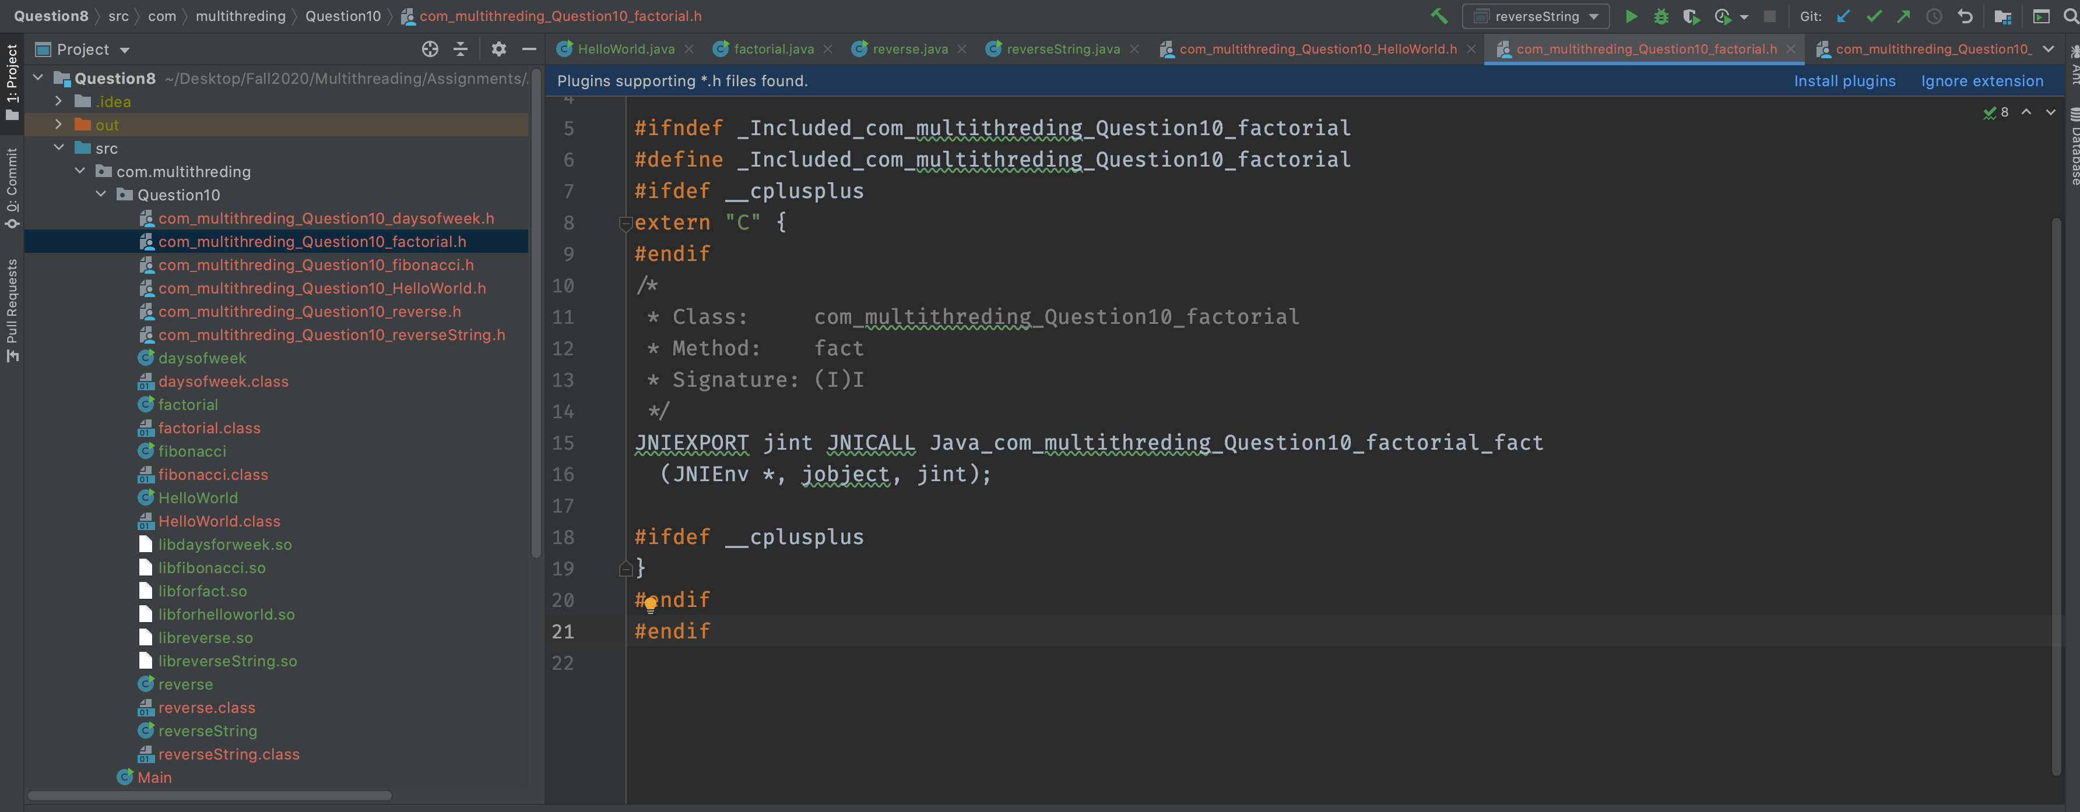

1. **Pass Strings from C to Java**

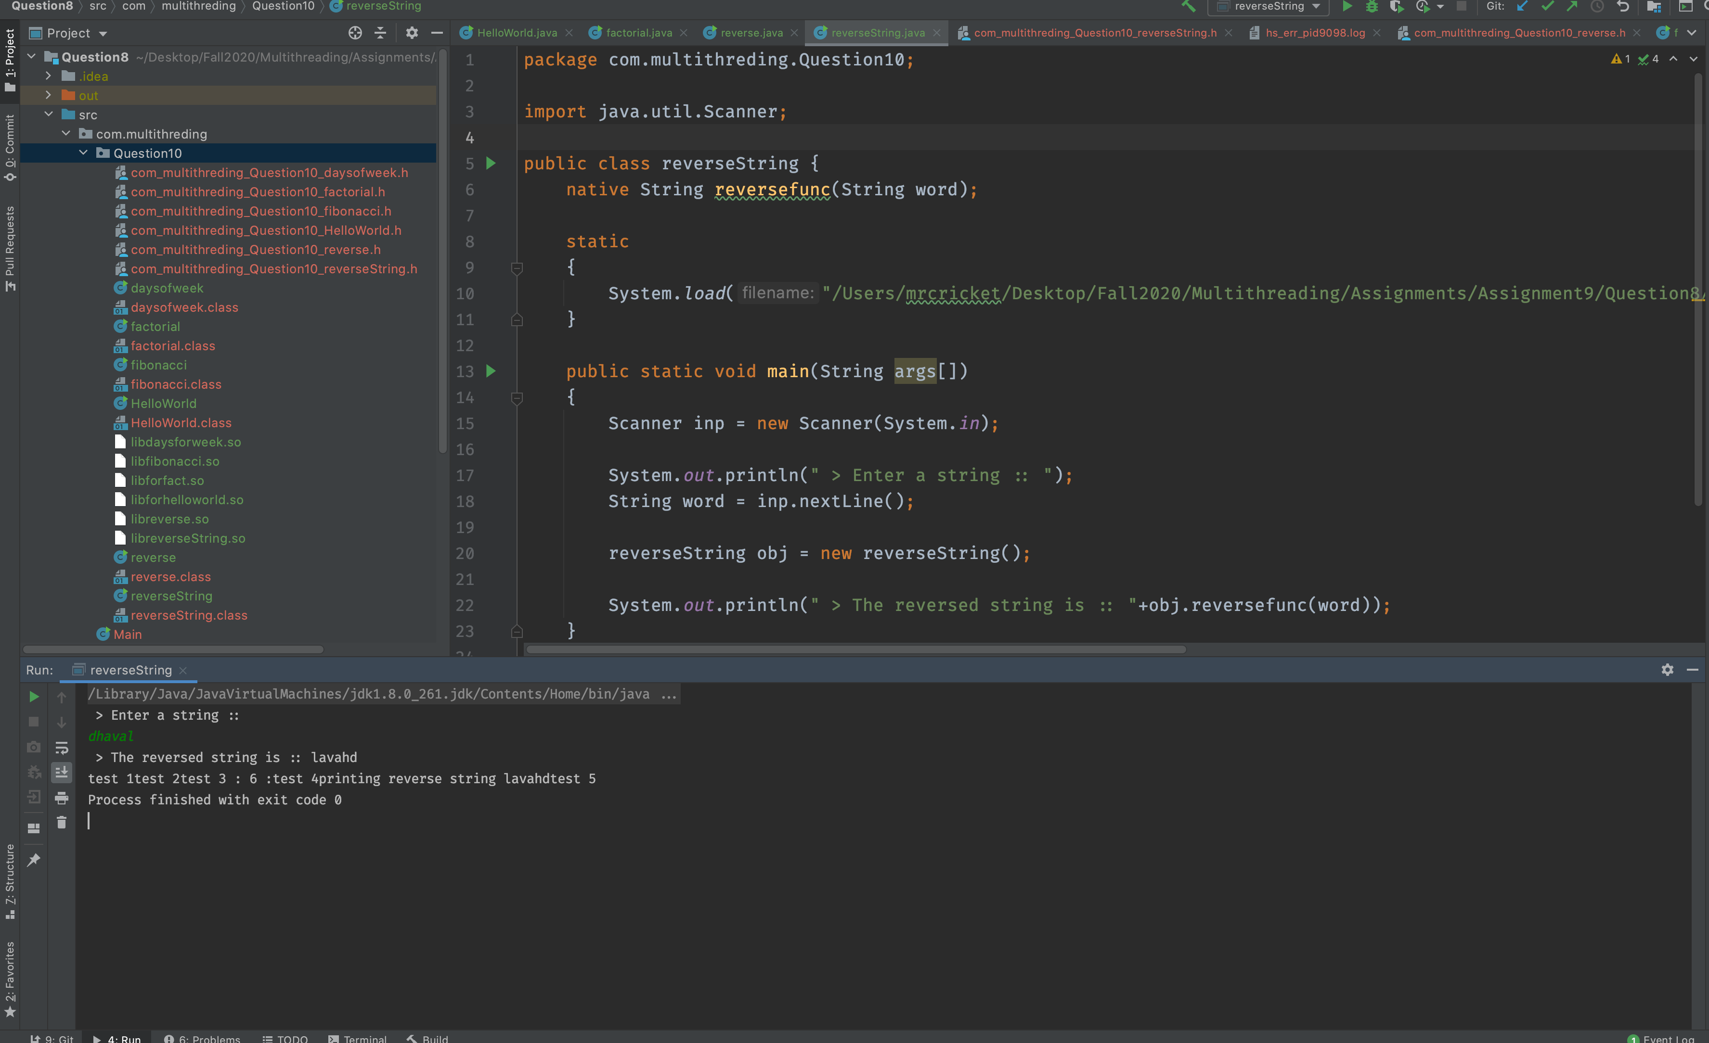

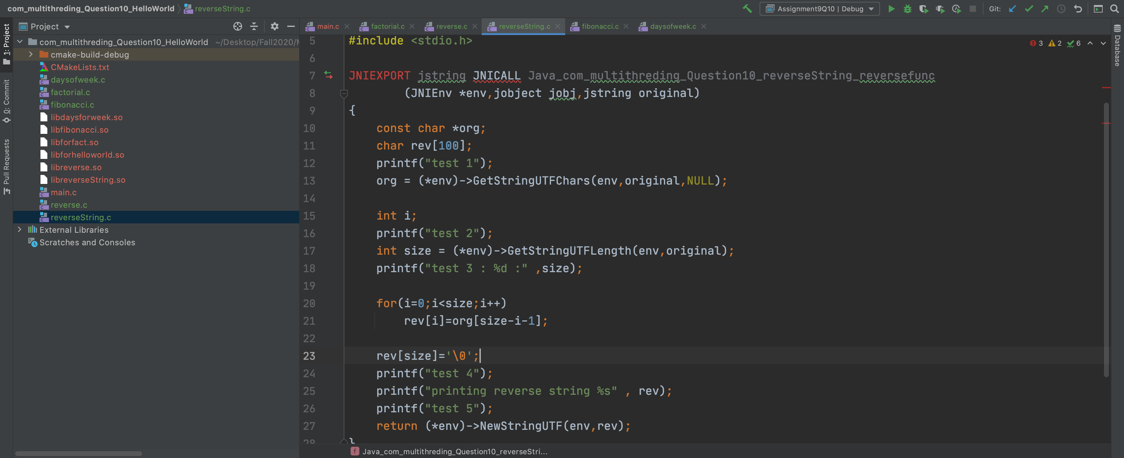

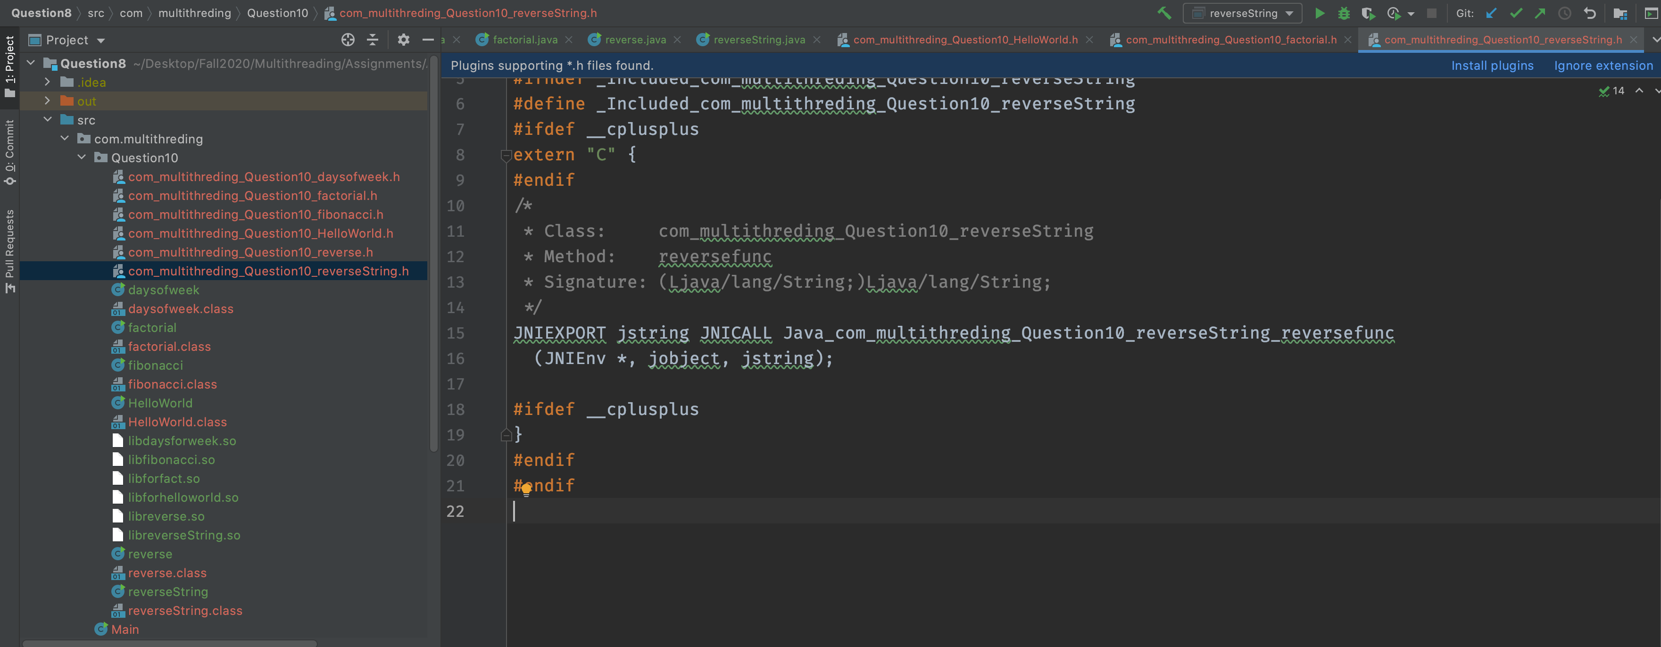

**d) Pass Integer Arrays From C to Java**

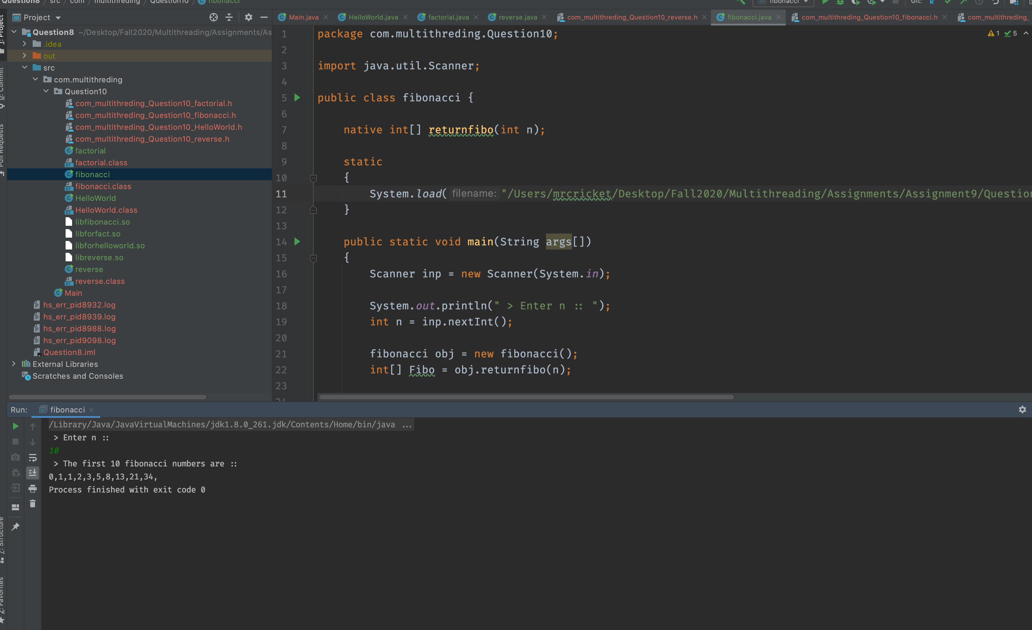

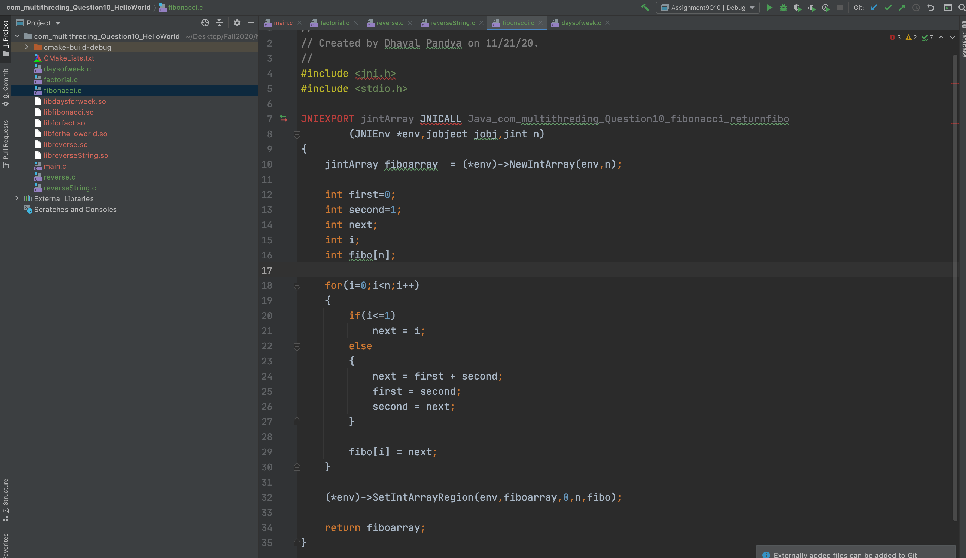

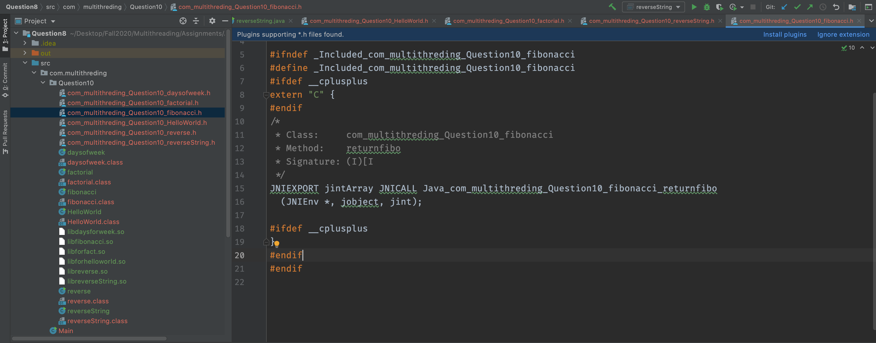

**f) Pass String Arrays From C to Java**

